SPH3U0 Ohm’s Law Lab Name:___________Partners:___________

**Task Overview:** In this activity, you will perform an experiment to verify Ohm’s Law. You will determine the nature of the relationship between voltage and current. You will also determine the value of the resistor tested using graphical analysis.

**Materials:**

2 AA batteries, resistor, Snap circuit board, 7 wires, potentiometer, digital multimeter, voltmeter

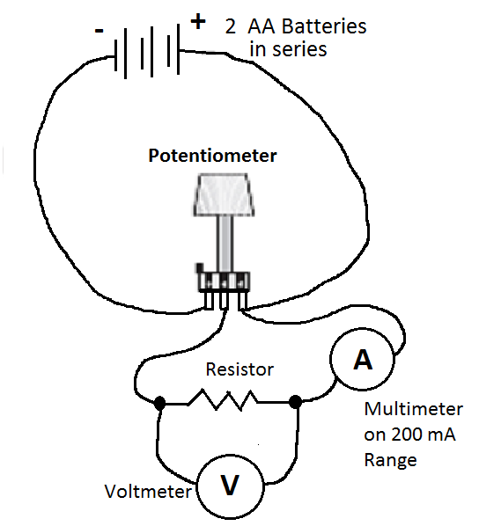

Wire 2

Wire 1

Figure 1: Circuit for investigating

Ohm’s Law.

Wire 3

Wire

5

Wire

4

Wire

7

Wire

6

Procedure:

1. Place the battery pack on the plastic snap on the edge of the circuit board. Place the resistor component in the middle of the board.
2. Orient the potentiometer so that the 3 metal terminals (connection points) are pointing towards you. Turn the knob fully counterclockwise. Connect the negative terminal of the battery to the left terminal of the potentiometer with a wire (wire 1 on the diagram). Connect the positive terminal of the battery to the right most terminal of the potentiometer (wire 2).
3. Connect a another wire to the wire attached to the right terminal of the potentiometer (wire 3). Since the terminals are very small, you will need to attach the second wire directly onto the metal clip of the first wire. Connect this wire to the red lead of the multimeter.
4. Now attach wire 4 from the black lead of the multimeter to one side of the resistor.
5. Connect the other side of the resistor with the MIDDLE terminal of the potentiometer (wire 5). Make sure that the metal clips of the four wires attached to the potentiometer are NOT touching.

**6.** Use the remaining wires (wire 6 and 7) to attach voltmeter across the resistor. Use the 1 V red terminal on the voltmeter. Again, you will need to clip these wires onto the metal clips of wires 4 and 5.

**7.** Call the teacher over to check your circuit! Then begin to slowly turn the knob on the potentiometer and observe the readings on the voltmeter and ammeter. If either of the readings are negative, then switch the connections on the meter. You should see both the current and voltage values change as the knob is turned. The current should a maximum value of about 25.0-30.0 mA. The voltage should reach a maximum value of about 2.50-3.00 V. You are now able to collect data.

**8.** Turn the knob counterclockwise so that the current and voltage return to zero. . .

**9**. Slowly turn the knob clockwise and measure the current and voltage values at LEAST 6 times over the full range of values. You should collect values approximately every 5.0 mA.

**10.** Record overall uncertainties for the current and the voltage values at the top of your chart.

**Sample Table 1:** Current versus Voltage Applied Across the Resistor

|  |  |
| --- | --- |
| Current (mA)  (± _____ mA) | Voltage Drop (V)  (± _____ V) |
|  |  |
|  |  |

Analysis and Discussion

1. Plot a graph of Voltage vs. Current. Describe the shape of the graph and determine the relationship between Voltage and Current.
2. Relate the shape of the graph to the equation for Ohm’s Law. Given that the resistance is a constant value (for any given resistor), does the shape of the graph agree with the predicted relationship between voltage and current from Ohm’s Law?
3. Determine the overall resistance of this resistor from the slope of the graph. To find resistance in Ohms, you will need to convert the slope units from Volts per milliAmpere (V/mA) to Volts per Ampere (V/A).
4. How does the average resistance compare with the printed value of the resistance on the resistor? Calculate the percentage error. If the percentage error is less than 10% we will assume the values agree well within experimental error. Does the experimental value agree reasonably well with the stated value? Please explain!

Conclusion

Provide a final summary which addresses the following points:

• how the resistance was determine

• the experimental value found for the resistance

• the agreement between experimental resistance value and the manufacturer resistance value.

Summarize if Ohm’s Law was verified by your experiment.

**Ohm’s Law Lab Marking Scheme Name: ___________________________**

**Inquiry: _____/24 marks**

**Lab Title, Date, Group Members,** 0 1

**Purpose Materials** 0 1

**Observation Chart**

Title 0 1

Column headings and units 0 1

Appropriate precision & uncertainties for I and V 0 1 2

Correct current conversion to Amperes 0 1

**Graph**

Title, axes labels and units 0 1 2

Appropriate axes scales 0 1 2

Correctly plotted points 0 1 2

Appropriate best fit line 0 1 2

**Analysis and Discussion**:

Slope calculation to find Resistance 0 1 2

Comparison with stated resistor value (% Error) 0 1 2

Discussion of Graph trends and relation to Ohm’s Law 0 1 2

Discussion calculated and stated resistance comparison 0 1

**Conclusion**: 0 1 2

**Ohm’s Law Lab Marking Scheme Name: ___________________________**

**Inquiry: _____/24 marks**

**Lab Title, Date, Group Members,** 0 1

**Purpose Materials** 0 1

**Observation Chart**

Title 0 1

Column headings and units 0 1

Appropriate precision & uncertainties for I and V 0 1 2

Correct current conversion to Amperes 0 1

**Graph**

Title, axes labels and units 0 1 2

Appropriate axes scales 0 1 2

Correctly plotted points 0 1 2

Appropriate best fit line 0 1 2

**Analysis and Discussion**:

Slope calculation to find Resistance 0 1 2

Comparison with stated resistor value (% Error) 0 1 2

Discussion of Graph trends and relation to Ohm’s Law 0 1 2

Discussion calculated and stated resistance comparison 0 1

**Conclusion**: 0 1 2